Week in Review, Issue 7, December 14-20
Alex Shvartsman

One Less Pro Tour
By far the biggest news of the week is cancellation of Pro Tour: Columbus. Some players, especially those holding full-time jobs or attending school full time complained that it is difficult for them to attend so many events. Indeed, while some players are unhappy about a loss of this Pro Tour stop, there has been many voices from top pros (Rafaelle Lo Moro is a notable example) supporting the change.
The prize money that would otherwise be given out in Columbus is being spent on a variety of programs detailed in this press release. Most of it will go increasing the prize fund for the World Championship tournament, and finally providing prize support to the National Championships around the world.

New DCI Policy Manager Hired
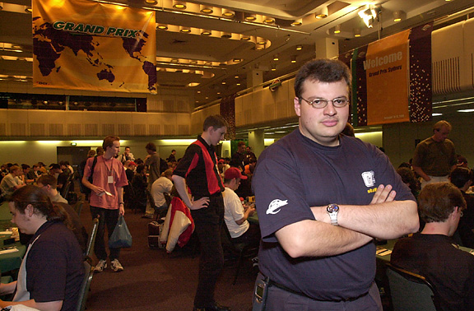
Chris "Bonecrusher" Zantides
Chris Zantides, a level 4 judge from Australia, has been hired to fill the shoes of the DCI Policy Manager position.
DCI Policy Manager has many responsibilities. Perhaps the most recognized by the players is that of conducting investigations of any alleged improper conduct in the DCI tournaments. In other words, this is the guy that comes after you if you are caught stacking your deck.
Chris Zantides has been previously employed by DCI Australia. He also head-judged many Grand Prix tournaments in Asia and South America and remains active in judging Pro Tour events. The DCI Manager position was previously held by Jason Carl and, most recently, Elaine Chase.

The Sky Is Not, In Fact, Falling

Some Magic fans around the internet were brought to the state of near panic by the announcement of cutbacks at Hasbro in general and Wizards of the Coast in particular. Before you go off building bomb shelters and hoarding water and Fallen Empires booster packs, let me assure you that the world has not ended.
Few if any of the recent changes will have an effect of the folks at WotC that are responsible for designing new Magic cards or running your tournaments. Every serious business goes through the kind of financial ups and downs Hasbro has been experiencing. It will not affect you as a consumer.

Old Pros Return
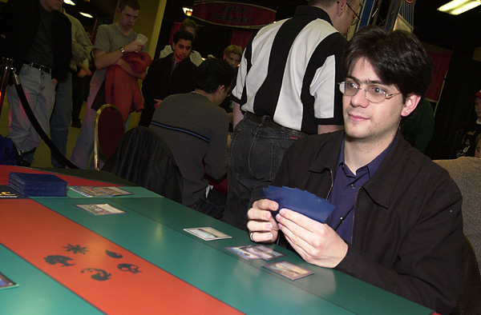
Canada's Terry Borer
Some players say no one really quits Magic - they might take a break for a while, but they always come back. In case of a pair of Pro Tour winners, this is definitely true. PT Mainz winner Matt Place has recently returned to the world of Magic. After a couple of months of playing at PTQs, he qualified for Pro Tour: Tokyo last weekend and will likely be attending. Both Frank Adler and Terry Borer attended PT-Chicago. Another Pro Tour winner, Olle Rade has recently come back to playing Magic as well. He too won a PTQ in Sweden and will be attending PT Tokyo. Who knows, perhaps Rade will finally submit a card he is allowed to design as a result of winning the Magic Invitational all those years ago.
Rumor has it, Brian Weissman, creator of The Deck, may start playing again. Like I said, no one really quits...

Team Draft Tournament
There are no major events happening until next month, but Magic players are easily amused. Many pros and casual players alike are using this respite to try out some new things.
Neutral Ground: New York is known for many things - but the favorite pastime of its regulars is 2 on 2 team draft. Four players draft out the cards and play two rounds. If the match score is 2-2, each team chooses a representative to play a tiebreaker match. The winning team keeps the cards.
This format is so popular, Brian David-Marshall had a brilliant idea of running a non-sanctioned tournament of it! A total of 10 teams showed up, including such pairings as Zvi Mowshowitz and Matt Urban, or Mike Pustilnik and myself.
The final match was played between a team of internet columnists Mike Flores and recently qualified Paul Jordan and the local favorites - roommates Brook North and Erik Kesselman. Kesselman and North won the prize - all cards opened in the process of this tournament.
"Who ends up with four Devouring Strossuses and no Absorbs or Undermines," lamented North about the quality of the cards they won. Ah well, at least they got that foil Ghitu Fire opened in one of my drafts.
Are there any interesting events like this happening in your home town? Let me know at ashv@concentric.net

Trading Trends
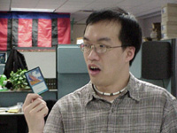
Players everywhere have been amazed by the new promo.
A brand new promotional card is now available. This time it is a foil version of the DCI Counterspell (illustrated by Dom!). This card is the latest in the series of "judge promos" that included Stroke of Genius, Lightning Bolt, Gaea's Cradle and Vampiric Tutor.
These cards are awarded to those fans who volunteer their time as judges, staff and reporters at Pro Tour and Grand Prix events. And if you are too busy to do that, well, there are some to be found on conspicuously online.

Best of the Net
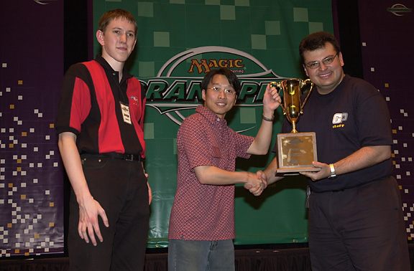
Barclay, left, with GP Sydney champ Gordon Lin and Bonecrusher Zantides
Paul Barclay is best known as a judge and a WotC Netrep. Who knew he could build decks, as well? Barclay's Extended deck "Full English Breakfast" has intrigued players worldwide. Even Zvi Mowshowitz, notorious for designing strange decks, proclaimed that he will "play F.E.B. at Worlds if he isn't in contention for Top 8 on Day 3." You can find Paul's report and deck list here.

Bad Play of the Week
And now for something completely different. Instead of describing a brilliant play, this time around I am going to talk about a horrible error.
A certain player was facing Justin Gary at Grand Prix: Helsinki. He just made a minor error and was upset about it. So upset in fact, that he put down his five-card hand and spent some time thinking about the board situation, before letting Justin take his next turn.
On the following turn, this player drew and played his card. The game went on for a while longer, yet this player never looked at the cards he had set aside. Justin Gary, whose draws weren't very good, managed to pull out of this situation and eventually win the game.
After the result slip has been signed, Justin asked his opponent about those five cards. To his horror, the other player realized that he simply FORGOT about the five cards he had! Upon examination, those cards had some excellent creatures and removal, plenty to make sure Justin should have never won that game.
Lesson of the day - keep your hand where you can see it at all times!
Got an interesting story that belongs in this column? Please e-mail me at ashv@concentric.net

